Database Management System

Retail Chain Initiative
Authored by: Mahmoud Elmahdy 01-09-2024



HR Database Management System
Project Report & System Overview
Organization: Retail Chain Initiative

Table of Contents
- Introduction
  - Project Purpose and Scope
- Database Architecture
  - Database Schema Components
  - Entity-Relationship Diagram (ERD)
- Core System Functionalities
  - Data Retrieval & SQL Queries
- Key Project Achievements
- Future Enhancements
- License

1. Introduction
This report details the design and implementation of a comprehensive HR Database Management system tailored for a retail chain organization. The system is engineered to be the central repository for managing all critical HR functions across multiple store locations.
Project Purpose and Scope
The primary objective is to streamline HR operations by effectively managing:
- Employee Records
- Store and Department Structures
- Job Roles and Assignments
- Employee Attendance and Warnings
- Performance Evaluations and Vacation Requests
2. Database Architecture
The database is built on a relational model to ensure data integrity and scalability. The design includes distinct tables for each core HR function.
2.1. Database Schema Components
The logical schema of the database is composed of the following tables:
- Store
- Department
- Job
- Employee
- Attendance
- Evaluation
- Vacation
- Warning
- Work Assignment

2.2. Entity-Relationship Diagram (ERD)
The following diagram illustrates the relationships between the tables in the HR database, showcasing primary and foreign key connections.
Figure 1: ER Diagram of the HR Management System
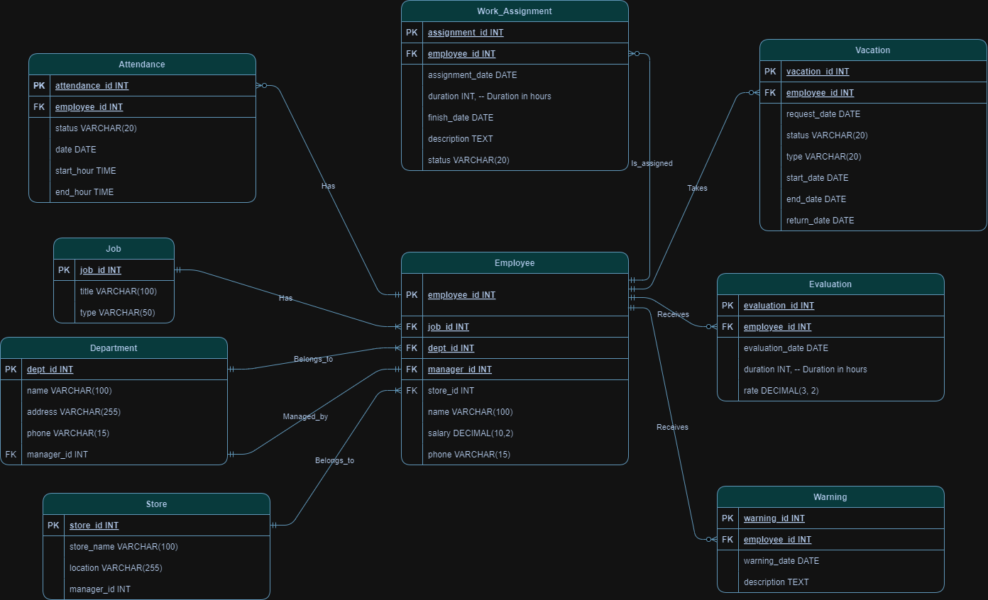
3. Core System Functionalities
The system leverages a series of structured query language (SQL) scripts to facilitate complex data retrieval and analysis, enabling data-driven HR decisions.
3.1. Data Retrieval & SQL Queries
The system can perform the following key operations:
- Generate full employee details for any specified department.
- Produce an organizational chart listing employees with their respective managers and contact details.
- Retrieve the complete history of disciplinary warnings for any employee.
- Analyze and compare individual employee salaries against the company-wide average salary.
- Identify departments that have a higher-than-average count of employee warnings.
- Track assignments for an employee within a specific timeframe.
- Aggregate and list the total number of warnings for each employee.
- Monitor all ongoing work assignments within a specific department.
- Query employee attendance records, including sign-in and sign-out times, for a given date range.
- Identify employees whose unexcused absences surpass a defined threshold.
- Pinpoint top-performing employees based on consistently excellent evaluation scores.
- Compile the full performance evaluation history for any employee.
- List all performance evaluations that were conducted by a particular manager.
4. Key Project Achievements
This project successfully delivered a robust and scalable HR management solution with several key outcomes:
- Comprehensive System Development: A complete HR database was developed to efficiently manage multifaceted HR data.
- Actionable Insights: Complex SQL queries were implemented to transform raw data into valuable insights for strategic HR decision-making.
- Scalable Architecture: A well-structured and normalized database design was created, ensuring it can support future growth and additional functionalities.
5. Future Enhancements
The current system provides a strong foundation for future development. The following enhancements are recommended to further increase its value and utility:
- Graphical User Interface (GUI): Implement a user-friendly interface to simplify data entry, management, and retrieval for HR personnel.
- Reporting & Analytics Dashboard: Add advanced reporting features and visual analytics to track key performance indicators (KPIs) and trends.
- System Integration: Integrate the database with external systems, such as payroll and time-tracking software, to create a unified HR ecosystem.
- Security & Access Control: Implement role-based access control and robust data security measures to protect sensitive employee information.

6. License
This project is licensed under the terms of the MIT License. Please refer to the LICENSE file for complete details.

